CONTACT MANAGEMENT SYSTEM
1. Project Overview
Description
The Contact Management System is a menu-driven Python application developed using Functions and Dictionaries. It allows users to manage contacts by adding, searching, updating, deleting, and viewing contact details. The application stores all contact information permanently in a JSON file and also provides the option to export data into CSV format.
The project demonstrates the practical use of Python programming concepts including dictionaries, functions, file handling, validation, exception handling, and modular programming.

2. Project Objectives
The objectives of this project are:
- Learn Python Functions
- Learn Dictionary Data Structure
- Perform CRUD Operations
- Implement Input Validation
- Store Data Permanently
- Export Data to CSV
- Practice Modular Programming
- Improve Problem Solving Skills
3. Technologies Used
Technology | Purpose
Python 3 | Programming Language
JSON | Permanent Storage
CSV | Export Contacts
re Module | Email & Phone Validation
datetime | Timestamp Management
os Module | File Handling

4. Project Structure
week3-contact-manager/
│── contacts_manager.py
│── contacts_data.json
│── contacts_export.csv
│── test_contacts.py
│── README.md
│── requirements.txt
└── .gitignore
5. Installation & Setup
Step 1
Clone the repository
git clone < https://github.com/mohit-214/week3_contact_manager_system/tree/main/contant%20management%20System >
Step 2
Move to project folder
cd week3-contact-manager
Step 3
Install dependencies
pip install -r requirements.txt
Step 4
Run the project
py "c:/Users/Mohit/contant management System/Contact Management System.py"

6. Code Structure Explanation
The project is divided into multiple reusable functions.
Each function performs only one task.
This improves
- Readability
- Reusability
- Maintainability
Major functions include:
- add_contact()
- search_contacts()
- update_contact()
- delete_contact()
- save_contacts()
- load_contacts()
- export_to_csv()
- view_statistics()
7. Features
✔ Add Contact
✔ Search Contact
✔ Update Contact
✔ Delete Contact
✔ Display Contacts
✔ JSON Storage
✔ CSV Export
✔ Contact Statistics
✔ Phone Validation
✔ Email Validation
✔ User Friendly Menu
✔ Error Handling
8. Function Explanation
validate_phone()
Purpose
Validates phone numbers.
Checks
- Only digits
- Length between 10–15 digits

validate_email()
Purpose
Checks whether the email format is valid using Regular Expressions.

add_contact()
Purpose
Adds a new contact after validating all inputs.
Stores
- Name
- Phone
- Email
- Address
- Group
- Date Created
- Updated Date

search_contacts()
Purpose
Searches contacts using partial matching.
update_contact()
Purpose
Updates existing contact details.

delete_contact()
Purpose
Deletes selected contact after confirmation.

save_contacts()
Purpose
Stores dictionary data into JSON.

load_contacts()
Purpose
Loads contacts from JSON file.

export_to_csv()
Purpose
Exports contacts into CSV format.

view_statistics()
Purpose
Displays
- Total Contacts
- Group-wise Contacts
- Recently Updated Contacts
9. Input Validation
The application validates
✔ Contact Name
✔ Phone Number
✔ Email Address
This prevents invalid data from entering the system.

10. Error Handling
The project handles
- Missing JSON File
- Invalid Phone Number
- Invalid Email
- Empty Name
- Invalid Menu Choice
- JSON Decode Errors

11. JSON Data Storage
All contacts are stored inside
contacts_data.json
Each contact contains
- Phone
- Email
- Address
- Group
- Created Time
- Updated Time

12. CSV Export
Users can export all contacts into
contacts_export.csv
This allows data to be opened in
- Excel
- Google Sheets
- LibreOffice
13. Contact Statistics
The application displays
- Total Contacts
- Contacts by Group
- Recently Updated Contacts
This provides a quick summary of stored data.

JSON Data Persistence
Contacts are automatically saved after every change.
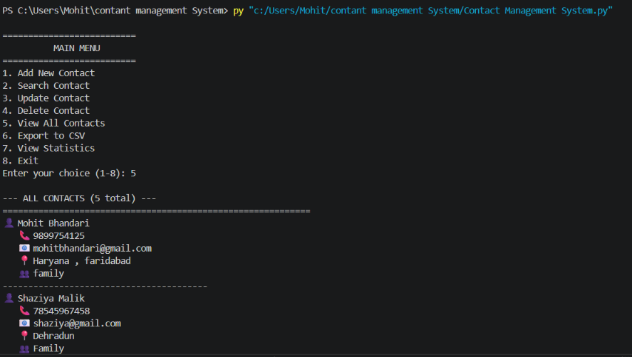
Example:

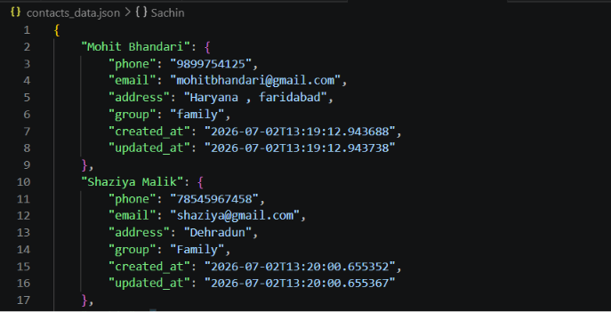

Advantages:
- Lightweight
- Human-readable
- Easy to edit
- Fast loading

14. Sample Output Screenshot
Add Contact
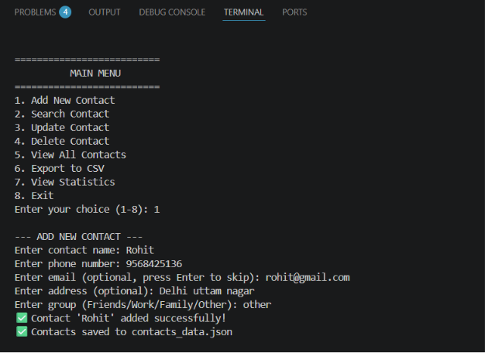
Search Contact
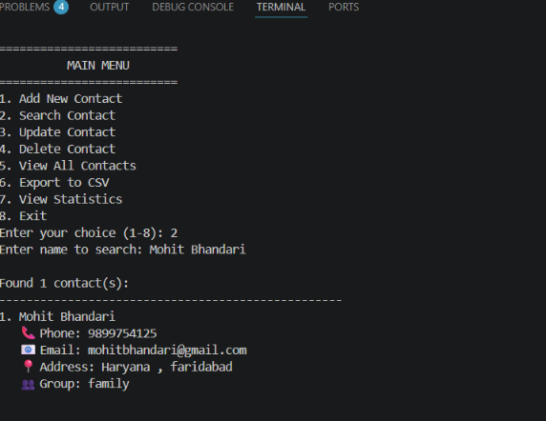

15. CSV Export
The application exports contacts into:
contacts.csv
Columns:
- Name
- Phone
- Email
- Address
- Group

16. Challenges & Solutions
Challenge 1
Duplicate contact names.
Solution
Implemented duplicate checking before saving.

Challenge 2
Phone validation.
Solution
Created validation logic supporting multiple formats.

Challenge 3
Searching efficiently.
Solution
Used case-insensitive partial matching with lower().

Challenge 4
Saving data permanently.
Solution
Used JSON with automatic saving after every operation.

Challenge 5
Handling file errors.
Solution
Implemented try-except blocks to prevent program crashes.

Author
Mohit Bhandari
Project: Contact Management System
Week 3 Mohit Bhandari

